Ocean Health Index

Preliminary Tanzania Assessment, 2018

**Pressure indicator**: Subtidal hard bottom habitat destruction using dynamite fishing as a proxy.

**Aim**: to acquire data on blast fishing from experts in Tanzania based on pre-existing primary data, reports, perception, observations and/or fisheries monitoring.

We seek to acquire information on the following:

1. Number of blasts per region/ district (if possible) across the entire coastline (please see figure 1 below).
2. The hotspot areas where blast fishing is prevalent/common.
3. Management, policy, monitoring and control measures in place to control/ prevent blast fishing (to measure effectiveness).

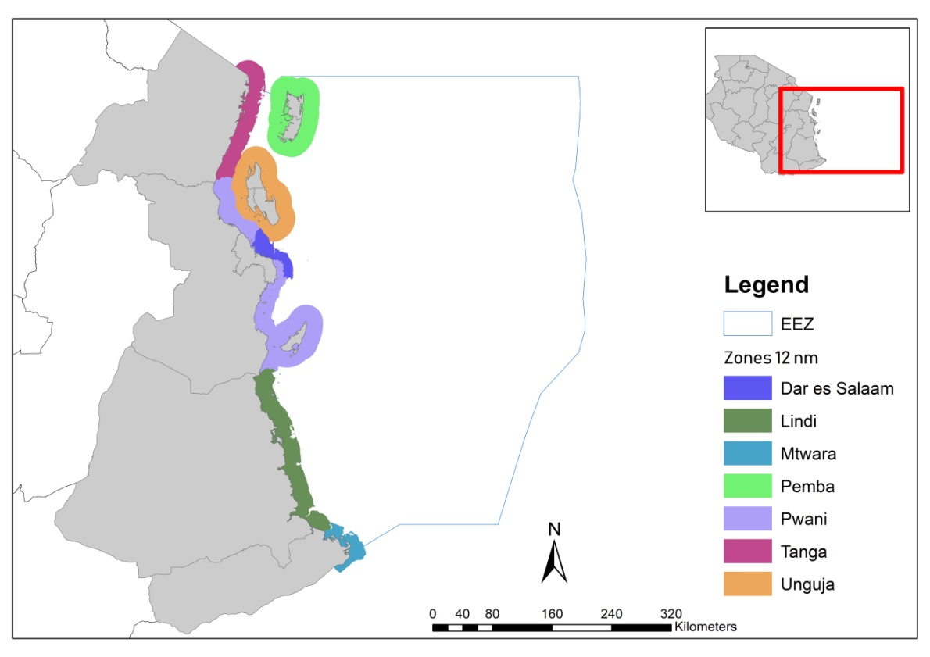

**Figure 1:** Map of Tanzania delineated into 7 zones for both mainland and Zanzibar extending up to 12nm offshore.

**Institutional information**

Name: Lindsey West

Designation: Director

Institution: Sea Sense

1. If you have data on blast fishing activities for any region on mainland and Zanzibar, please fill in the table below with;
   1. Summary information as per the relevant sections in table 1 below.

#### Table 1: Summary of blast fishing activity per region/ district and catch landed in mainland and Zanzibar regions.

|  |  |  |  |  |  |  |
| --- | --- | --- | --- | --- | --- | --- |
| Region | District | Blast site(s) | Year | Number of boats per area | Number of blasts | Management, policy, monitoring and control measures in place |
| DSM | Temeke | Amani Gomvu | 2008 | N/A | 72 |  |
| DSM | Temeke | Buyuni | 2008 | N/A | 17 |  |
| DSM | Temeke | Mbutu | 2008 |  | 45 |  |
| DSM | Temeke | Pemba mnazi | 2008 |  | 6 |  |
| DSM | Temeke | Visikini | 2008 |  | 11 |  |
| DSM | Temeke | Amani Gomvu | 2009 |  | 650 |  |
| DSM | Temeke | Visikini | 2009 |  | 405 |  |
| DSM | Temeke | Buyuni | 2009 |  | 378 |  |
| DSM | Temeke | Kimbiji | 2009 |  | 182 |  |
| DSM | Temeke | Mbutu | 2009 |  | 206 |  |
| DSM | Temeke | Pemba mnazi | 2009 |  | 71 |  |
| DSM | Temeke | Yale Yale Puna | 2009 |  | 3 |  |
| Tanga | Muheza | Kigombe | 2009 |  | 309 |  |
| Tanga | Tanga City | Machui | 2009 |  | 410 |  |
| Tanga | Tanga City | Mwarongo | 2009 |  | 113 |  |
| Tanga | Tanga City | Machui | 2010 |  | 6 |  |
| DSM | Temeke | Buyuni | 2010 |  | 40 |  |
| DSM | Temeke | Pemba mnazi | 2010 |  | 29 |  |
| DSM | Temeke | Visikini | 2010 |  | 315 |  |
| DSM | Temeke | Yale Yale Puna | 2010 |  | 16 |  |
| DSM | Temeke | Amani Gomvu | 2011 |  | 36 |  |
| DSM | Temeke | Buyuni | 2011 |  | 228 |  |
| DSM | Temeke | Kimbiji | 2011 |  | 90 |  |
| DSM | Temeke | Pemba mnazi | 2011 |  | 68 |  |
| DSM | Temeke | Visikini | 2011 |  | 316 |  |
| DSM | Temeke | Yale Yale Puna | 2011 |  | 96 |  |
| Coast | Rufiji | Pombwe | 2012 |  | 57 |  |
| DSM | Temeke | Amani Gomvu | 2012 |  | 21 |  |
| DSM | Temeke | Buyuni | 2012 |  | 50 |  |
| DSM | Temeke | Kimbiji | 2012 |  | 12 |  |
| DSM | Temeke | Pemba mnazi | 2012 |  | 34 |  |
| DSM | Temeke | Visikini | 2012 |  | 15 |  |
| DSM | Temeke | Yale Yale Puna | 2012 |  | 17 |  |
|  |  |  |  |  |  |  |
|  |  |  |  |  |  |  |
|  |  |  |  |  |  |  |

If you do not have data on blast fishing activity, please provide the following in the table below:

* Qualitative or expert opinion on known hotspot areas for blast fishing
* Append any other information that may be helpful to acquiring information on blast fishing.

#### Table 2: Qualitative/expert information on blast fishing/ hotspot areas.

|  |  |  |  |  |  |
| --- | --- | --- | --- | --- | --- |
| Region | District | Year | Area | Level of activity  (Please rate using this scale: 0 -none; 0.25 -in-frequent/once in a while; 0.5 -seasonally; 0.75 -every other day; 1 -daily) | Other information |
|  |  |  |  |  |  |
|  |  |  |  |  |  |
|  |  |  |  |  |  |
|  |  |  |  |  |  |
|  |  |  |  |  |  |
|  |  |  |  |  |  |
|  |  |  |  |  |  |
|  |  |  |  |  |  |
|  |  |  |  |  |  |
|  |  |  |  |  |  |
|  |  |  |  |  |  |
|  |  |  |  |  |  |
|  |  |  |  |  |  |
|  |  |  |  |  |  |
|  |  |  |  |  |  |
|  |  |  |  |  |  |
|  |  |  |  |  |  |
|  |  |  |  |  |  |
|  |  |  |  |  |  |
|  |  |  |  |  |  |
|  |  |  |  |  |  |